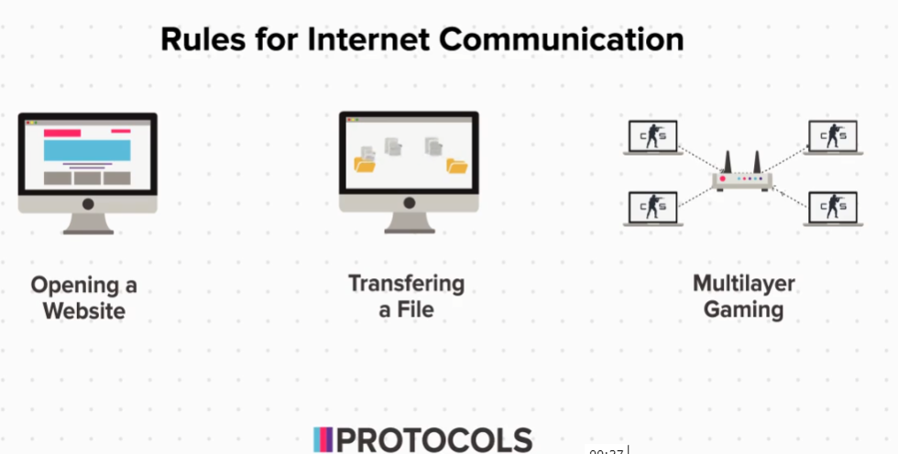

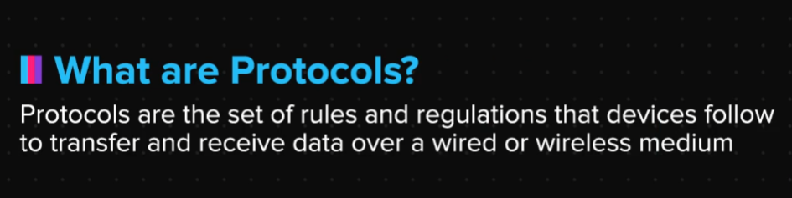

Looking at Common Protocols

Nodes follow different protocols for different functions. Here is a list of some common protocols.

HTTP: HTTP stands for Hyper Text Transfer Protocol and it is used to transfer hyper text, which means web pages.

HTTPS: This is the secure version of HTTP, where s stands for secured and is used to transfer web pages in a secured way. Most websites that we visit, like internshala, amazon, google, etc., use HTTPS and not HTTP.

The fact that it is secured means that all communications between your browser and the website you are connected to, will be encrypted.

You can see this in the address bar located at the top of the browser.

FTP: FTP stands for File Transfer Protocol and is used while transferring files.

SMTP: SMTP stands for Simple Mail Transfer Protocol and as the name suggests, it is used to send emails from one device to another. But when you open gmail, or compose and send an email, does your address bar show SMTP, or HTTPS. Well, try it and find out for yourself, and lookout for the reason somewhere in this topic.

Telnet: This protocol is used to remotely run system commands on the server.

SSH: SSH is Secure Shell and is like a secure or encrypted version of Telnet.

VOIP: This stands for Voice Over Internet Protocol and is used for making a voice call over the internet.

So while you are making calls over whatsapp or skype, VOIP is being used for this communication.

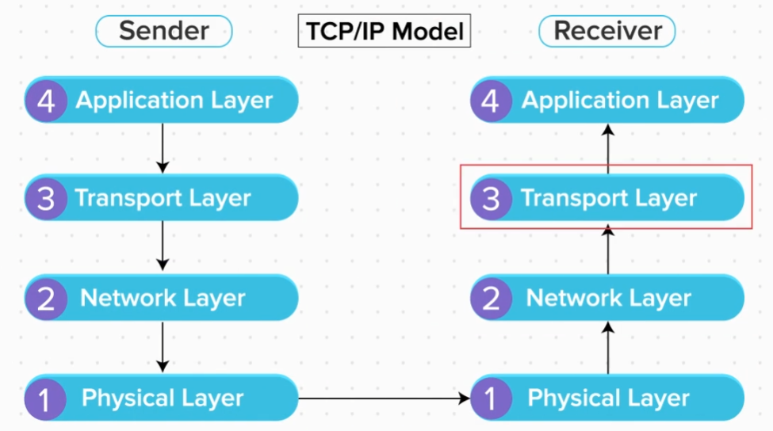

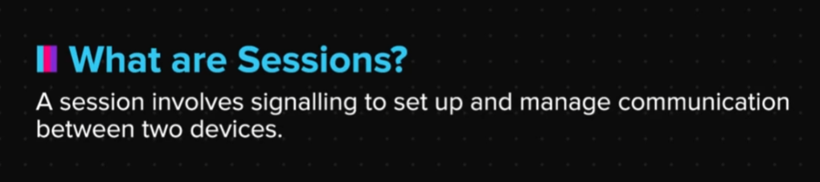

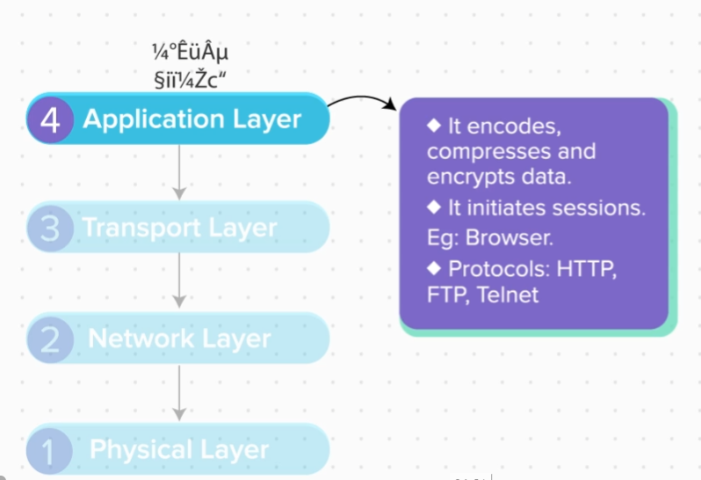

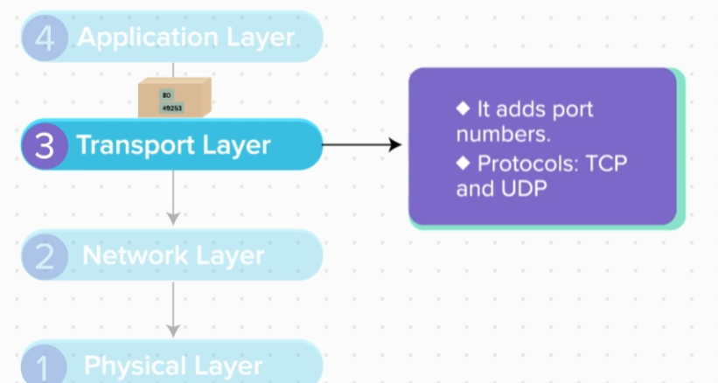

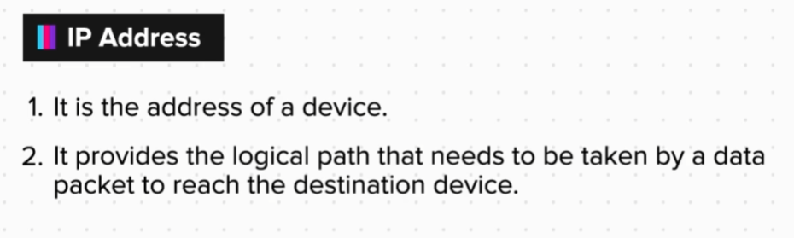

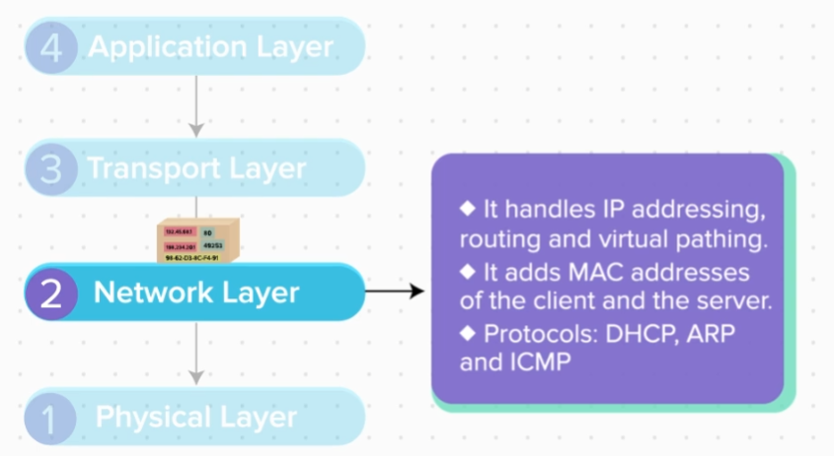

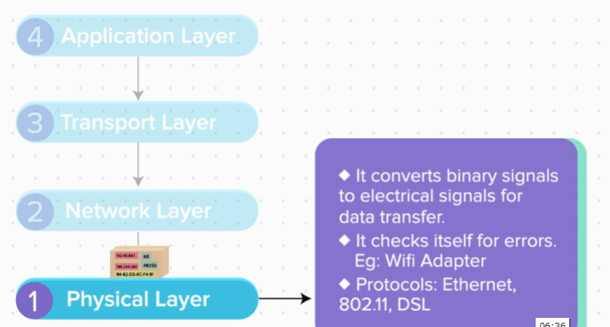

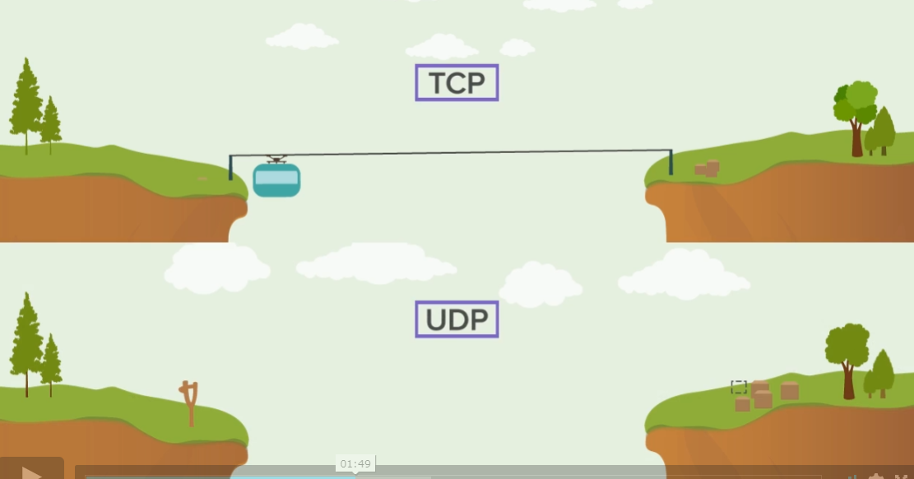

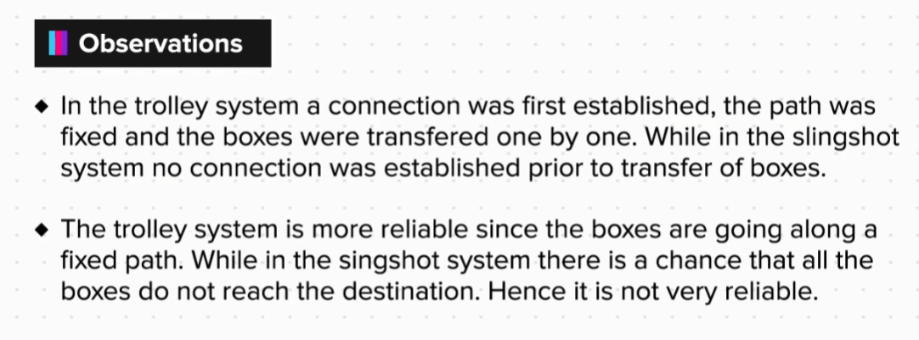

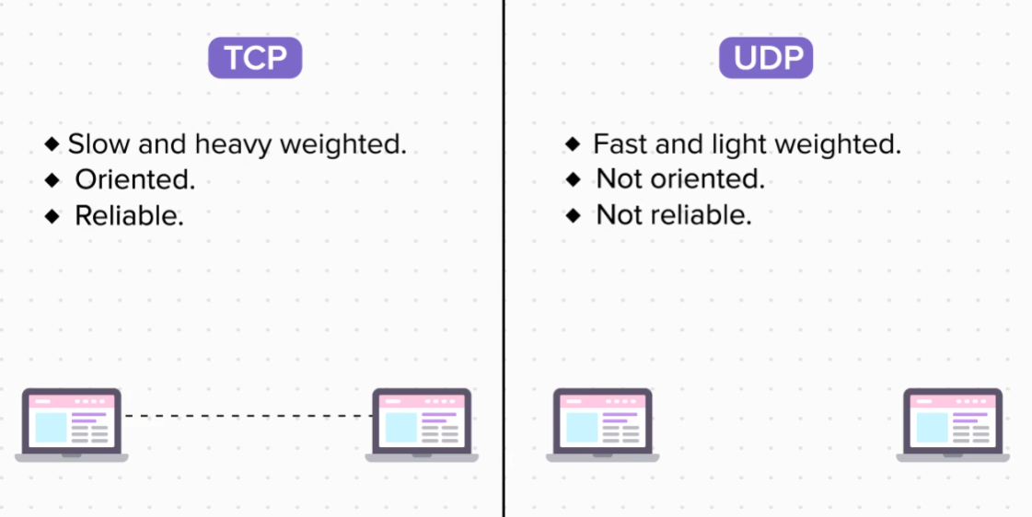

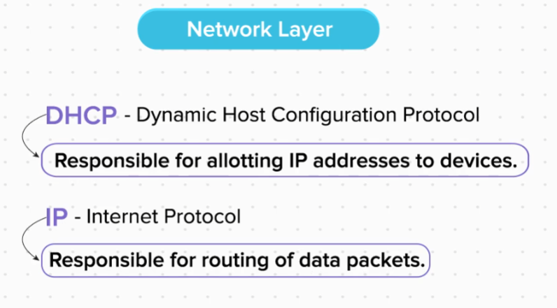

Understanding the OSI Model

OSI Model

So, we have seen the TCP/IP Model. Actually this was a derived model and is used today. But the original model on which the TCP/IP model was based, is called the OSI Model. This model has 7 layers, instead of 4 that we see in the TCP/IP model. The essential overall function of both the models remains the same, just that in the OSI model their work has been split into 7 layers.

Now let us look at the function of each layer of the OSI model in detail.

So, just like in the TCP/IP model, the data in the OSI model also passes from layer 7 to layer 1 at the sender’s end and from layer 1 to layer 7 at the receiver’s end.

Application Layer- This layer provides an interactive interface for the user to enter and view data. One can give inputs in the form of text, audio, images, files, etc. The browser makes up the application layer.

Presentation Layer- After the application layer, the data passes to the presentation layer. This is where the data is converted into computer friendly format, i.e in binary code. So, the presentation layer encodes the input, compresses it, and encrypts it if required. Then the data is sent to the next layer.

Session Layer- This layer initiates a connection and creates a session, so that some context can be provided to the communication between the two devices.

Transport Layer- This layer establishes an application level connectivity. For this, it attaches the source and destination port numbers.

It also performs the task of error control, which means that it makes a checklist, so that it can be cross checked at the receiving end to ensure that all the data is transferred properly and not destroyed on the way. These checklists are known as checksums.

Network Layer- At the network layer, the source and destination IP addresses are attached, for the purpose of identification of devices, and to decide the virtual path that needs to be taken by the data packet. So, we can say that this layer does network level routing and pathing of packets.

Data Link Layer- This layer attaches the source and destination MAC addresses, which are used to identify the hardware of the device. It also calculates checksums for error checking of the metadata that has been attached at all the previous layers, and also to manage the flow of data.

Physical Layer- This is where the data is converted to hardware friendly signals, like radio signals, light signals, or electric signals, depending on the hardware that is being used for data transfer.

This is the order in which the data passes at the sender’s end. At the receiver’s end, the order of the layers is reversed.

Now, don’t worry if you cannot remember all this information. We have some simple tricks for you. A simple mnemonic that can used to remember the order of the layers from layer 7 to layer 1 is:

All People Seem To Need Data Processing

So that was all about the OSI model.

Summary

Now that we have come to the end of this topic, you should be able to:

1. Understand the purpose of protocols.

2. Understand the concepts of packets and datagrams.

3. Describe the usage of commonly used protocols.

4. Differentiate between TCP and UDP protocols.

5. Understand the need for OSI model

6. Explain the different layers and working of the OSI model

7. Differentiate between the OSI and TCP/IP model